CS-320 Project Two: Summary and Reflections Report
Michael Lovett | Southern New Hampshire University | CS-320
Summary: Unit Testing and Requirements Alignment
For Grand Strand Systems, I developed and tested three back-end services using Java and JUnit 5. My approach was requirements-based: I translated each field constraint and service operation into a test that either verified expected behavior or rejected invalid input. The submitted Project One code contains 55 @Test methods across six test classes: 23 for contacts, 21 for tasks, and 11 for appointments (Lovett, 2026).
Contact tests check that IDs do not exceed 10 characters, first and last names do not exceed 10, phone numbers contain exactly 10 digits, and addresses do not exceed 30 characters. For example, ContactTest.testPhoneContainsLetters expects an IllegalArgumentException for “70355ABCDE.” ContactServiceTest.testAddDuplicateContactId verifies that the service rejects a second contact with the same ID; other tests cover adding, deleting, and updating contact information. TaskTest similarly rejects names longer than 20 characters and descriptions longer than 50; TaskServiceTest verifies duplicate-ID rejection and valid or invalid updates. AppointmentTest rejects past and null dates, long descriptions, and invalid IDs, while AppointmentServiceTest verifies add, duplicate-ID, delete, and missing-ID behavior.
The Eclipse JUnit 5 run executed all 55 tests successfully, with zero errors and zero failures (see Figure 1). Eclipse also measured 91.8% instruction coverage: 1,408 of 1,534 instructions were covered, while 126 were missed (see Figure 2). These results provide quantitative support for the effectiveness of my requirements-based tests across the three services, but instruction coverage is not the same as branch coverage or proof that every requirement and edge case was exercised. I would examine the uncovered instructions and add targeted boundary and failure-path tests to improve confidence (Hambling et al., 2019).
Summary: Technical Soundness and Efficiency
I made the tests technically sound by using explicit JUnit assertions tied to observable outcomes. In ContactServiceTest.testDeleteContact, the sequence service.deleteContact("1234567890") followed by assertNull(service.findContact("1234567890")) checks the result rather than merely calling the method. In TaskServiceTest.testAddDuplicateTaskId, assertThrows(IllegalArgumentException.class, () -> { service.addTask(duplicateTask); }) checks the required failure path. AppointmentTest.testAppointmentDateInPast creates a date using System.currentTimeMillis() - 86400000 and verifies that construction fails. These assertions make failures easier to interpret and link directly to requirements (Lovett, 2026).
I also kept tests efficient and repeatable by focusing each test on a single behavior and avoiding unnecessary dependencies. The @BeforeEach setUp() methods in ContactServiceTest, TaskServiceTest, and AppointmentServiceTest initialize a fresh service and example object for every test. This prevents changes made in one test from affecting another and reduces duplicated setup. The appointment tests use dates one or two days in the future rather than relying on a fixed calendar date; this makes them more durable, although a controllable clock would improve precision at date boundaries.
Reflection: Techniques and Practical Implications
The principal technique I used was automated, white-box unit testing: JUnit tests exercised constructors, setters, and service methods in isolation. Positive testing confirmed that valid records could be created, found, updated, or deleted; negative testing used assertThrows to confirm rejection of null values, invalid lengths, duplicate IDs, and nonexistent records. Boundary-oriented tests checked values beyond limits, such as an 11-character contact ID and a 9- or 11-digit phone number. This combination is appropriate for business rules because invalid data can otherwise spread through the application and cause later failures.
I did not implement full integration, system, acceptance, performance, security, or mutation testing. Integration testing would check whether these services interact correctly with persistence, APIs, and other components; system and acceptance tests would validate complete user workflows against customer expectations. Performance testing would assess response times as records grow, while security testing would examine authorization and malicious input. Mutation testing would deliberately alter code to see whether tests detect incorrect behavior. These techniques require additional infrastructure but become increasingly important in deployed applications, especially when service reliability and data protection affect users (Hambling et al., 2019).
A practical next step is to add exact-limit tests—such as a 10-character ID and a 20-character task name—plus tests for empty strings and state preservation after rejected updates. A coverage tool could then identify unexecuted statements and branches. For a larger production application, I would combine fast unit tests on every commit with integration and security tests in a continuous integration pipeline.
Reflection: Caution, Bias, and Professional Discipline
I approached testing cautiously because the classes are related: service methods rely on model validation, and a failure in either layer could undermine a workflow. For example, TaskService.updateName locates a task and then calls its setter; tests must consider both a missing ID and an invalid replacement name. Similarly, the appointment service must prevent duplicate identifiers even when the dates and descriptions differ. My Coast Guard engineering and industrial maintenance experience reinforces the need to check failure modes rather than assume that successful normal operation means a system is safe.
Testing my own code also creates confirmation bias: it is tempting to write cases that prove my implementation works instead of cases that challenge its assumptions. I limited that risk by including invalid inputs and exception assertions alongside successful operations. Still, I can improve by reviewing requirements before implementation, having another developer review tests, and writing cases specifically intended to break the program. A passing test suite should invite scrutiny, not end it.
Professional discipline means treating tests, documentation, and maintenance as part of the product rather than optional work. Skipping boundary cases or ignoring a failed test may save time initially but creates technical debt through future rework and unpredictable defects. I plan to avoid that debt by maintaining small readable methods, automating regression tests, reviewing coverage and failures, refactoring duplicate code, and updating tests whenever requirements change. Reliable software is built through repeatable verification and a willingness to correct weaknesses before release.
References
Hambling, B., Morgan, P., Samaroo, A., Thompson, G., & Williams, P. (2019). Software testing: An ISTQB-BCS certified tester foundation guide (4th ed.). BCS Learning & Development.
Lovett, M. (2026). CS-320 Project One: Contact, task, and appointment services and JUnit tests [Unpublished Java source code]. Southern New Hampshire University.

Appendix: Project One Testing Evidence
Figure 1. JUnit 5 results: 55 tests run, zero errors, zero failures.
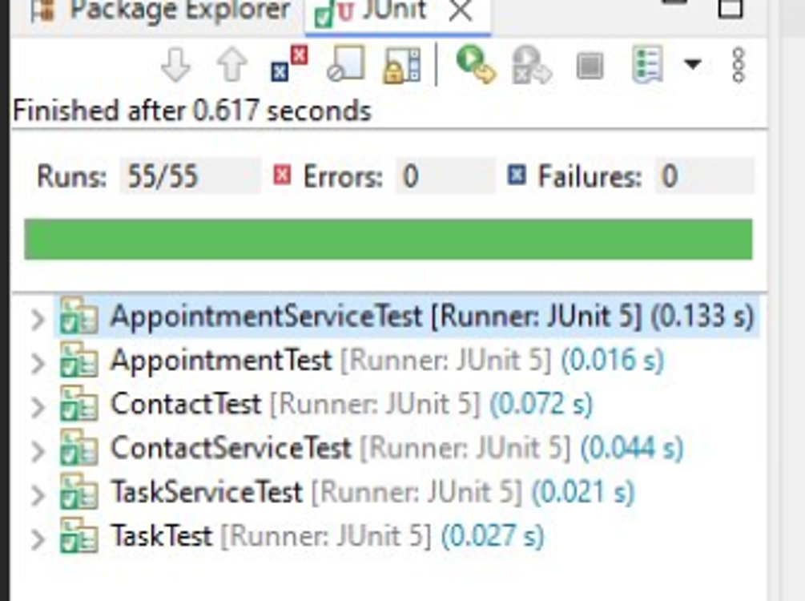
Figure 2. Eclipse instruction coverage: 91.8% (1,408 of 1,534 instructions).
